Фотографии с Tropheryma whipplei.

http://biologie.univ-mrs.fr/FAQbio/images/WD_SEMIMNAIRE.ppt
- Rod-shaped morphology (палочкообразное строение)
- Size: 0.2 x 2 µm (размер 0.2 x 2 µm (микрометров))
Trilamellar cell wall (тройная клеточная стенка)
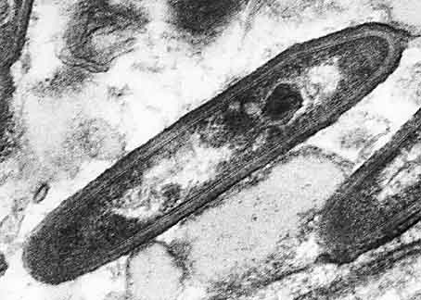

http://ijs.sgmjournals.org/cgi/reprint/51/4/1471.pdf

Cultivated cells of T. whipplei observed using an
inverted microscope on a 6-week-old culture.
(Изображение 6-недельной культуры T. whipplei, полученное с помощью инверсионного микроскопа)

http://ijs.sgmjournals.org/cgi/reprint/51/4/1471.pdf

Immunofluorescence
staining of the Whipple’s disease
bacterium isolate in
an infected HEL
cell monolayer in a shell
vial, revealed
by patient serum. Bar, 6 lm.

http://ijs.sgmjournals.org/cgi/reprint/51/4/1471.pdf

a c

b d

Electron microscopy of T. whipplei cultured in HEL cell monolayers. (a) Transmission electron microscopy of
T. whipplei (arrowheads) in HEL cells within vacuoles. Bar, 2 lm. (b) Transmission electron microscopy of two extracellular
T. whipplei cells, of which one is dividing. Bar, 100 nm. (c) Transmission electron microscopy and negative staining
of individual extracellular T. whipplei cells. Bar, 500 nm. (d) Scanning electron microscopy of aggregated extracellular
T. whipplei cells embedded in an extracellular matrix. Bar, 2 lm.

