Features
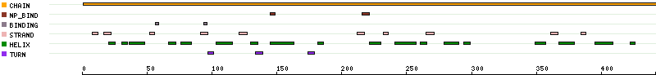
Key |  | Begin | End | Length | Description | RESID
 | CHAIN | 1 | 442 | 442 | Putative monooxygenase MoxC. /FTId=PRO_0000360622.
 | NP_BIND | 145 | 149 | 5 | FMN binding.
 | NP_BIND | 217 | 220 | 4 | FMN binding.
 | BINDING | 58 | 58 | 1 | FMN; via amide nitrogen and carbonyl oxygen.
 | BINDING | 95 | 95 | 1 | FMN.
 | STRAND | 8 | 12 | 5
 | STRAND | 18 | 21 | 4
 | HELIX | 22 | 24 | 3
 | HELIX | 32 | 34 | 3
 | HELIX | 36 | 48 | 13
 | STRAND | 52 | 56 | 5
 | HELIX | 68 | 71 | 4
 | HELIX | 76 | 84 | 9
 | STRAND | 91 | 97 | 7
 | TURN | 98 | 100 | 3
 | HELIX | 103 | 116 | 14
 | STRAND | 121 | 127 | 7
 | HELIX | 131 | 134 | 4
 | TURN | 135 | 138 | 4
 | HELIX | 145 | 163 | 19
 | TURN | 175 | 178 | 4
 | HELIX | 183 | 185 | 3
 | STRAND | 213 | 216 | 4
 | HELIX | 221 | 230 | 10
 | STRAND | 232 | 236 | 5
 | HELIX | 241 | 257 | 17
 | HELIX | 262 | 264 | 3
 | STRAND | 265 | 271 | 7
 | HELIX | 279 | 290 | 12
 | HELIX | 295 | 298 | 4
 | HELIX | 349 | 357 | 9
 | STRAND | 362 | 365 | 4
 | HELIX | 367 | 379 | 13
 | STRAND | 384 | 388 | 5
 | HELIX | 395 | 409 | 15
 | HELIX | 422 | 426 | 5

Sequence information
Length: 442 aa, molecular weight: 49411 Da, CRC64 checksum: 8C9D72FEB983FBF5

