Description of O.Yellows phytoplasma, OY-M, and its proteome

K. Yashina

Introduction.

Taxonomy:
- Group Tenericutes
- Class Mollicutes
- Order Acholeplasmatales
- Family Acholeplasmataceae
- Genus Candidatus Phytoplasma
- Species Onion yellows
- Strain OY-M

Structure:
Virions filamentous; not enveloped; usually flexuous; with no clear modal length; of 772 and 823 nm (Schmidt and Schmelzer, 1978)). Axial canal obscure. Basic helix obscure.

Habitat:
From minus 4 to 60-65 °C, life expectation: 2-3 days, infectivity of sap not changed by treatment with di-ethyl ether, leaf sap contains few virions. Probably distributed worldwide.

Phytoplasmas are a group of microscopic organisms that cause over 700 diseases in plants. Phytoplasmas grow and multiply within host plants and insect vectors. In host plants, phytoplasmas are found only in the phloem tissue of leaves, stems, and roots. When the concentration of phytoplasmas within the plant reaches a certain level, it is believed to cause hormonal imbalance, resulting in the development of symptoms such as chlorotic leaves, stunting, flower petals changing to a green color (phyllody or virescence), and witches-broom (shoot proliferation).
(Source http://www.ctahr.hawaii.edu/watercress/IP-20%5B1%5D.pdf)

***

Onion yellows phytoplasma causes a yellowing disease in onions
Phytoplasmas associated with yellows diseases were firstly described in 1926 by Kunkle in American aster plants showing virescence and flower malformations. Since then the etiological agent of this and of similar diseases was believed to be a virus; until in 1967 Doi et al. detected under electron microscope phytoplasmas in aster and other plants with "yellows" symptoms opening phytoplasmology history.
Like other mollicutes, phytoplasmas lack cell walls, are pleomorphic and reside endocellularly in insects and plant phloem. Onion yellows phytoplasma is a parasite that lives inside leafhopper insects and spreads to plants through the saliva of feeding insects.
The metabolic pathways and host interactions of Onion yellows phytoplasma is of interest in agricultural and basic sciences. The inability to culture phytoplasmas in vitro has hindered their characterization at the molecular level, the determination of factors involved in their pathogenicity and the discovery of effective ways to control or cure phytoplasma diseases.
Analysis of the phytoplasma genome suggests reductive evolution as a consequence of its life as an intracellular parasite in a nutrient-rich environment and shows that phytoplasma lacks several genes previously considered to be essential for autonomously replicating cells. Instead, it possesses transporter genes involved in the uptake of substances from the cytoplasm of surrounding host cells. Although it is difficult to define the minimal genome concept for pathogens and symbionts that rely on their hosts, phytoplasmas are unique bacteria that contain a new minimal gene set.
Source: http://www.ebi.ac.uk/2can/genomes/bacteria/Onion_yellows_phytoplasma.html

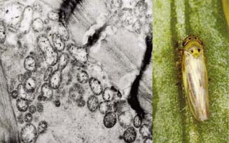
Phytoplasma Onion yellows (left) is transmitted by Macrosteles striifrons (right) specifically
(source http://narc.naro.affrc.go.jp/narc-e/page7/p7.html)

***

Annotation of one of the articles about O.Yellows:
Source http://mic.sgmjournals.org/cgi/reprint/150/1/135.pdf

Secretion of immunodominant membrane protein from onion yellows phytoplasma through the Sec protein-translocation system in Escherichia coli
A gene that encodes a putative SecE protein, which is a component of the Sec protein-translocation
system, was cloned from the onion yellows phytoplasma (OY). The identification of this gene
and the previously reported genes encoding SecA and SecY provides evidence that the Sec
system exists in phytoplasma. In addition, a gene encoding an antigenic membrane protein (Amp)
(a type of immunodominant membrane protein) of OY was cloned and sequenced. The OY
amp gene consisted of 702 nt encoding a protein of 233 aa which was highly similar to Amp of
Aster yellows phytoplasma (AY). Part of OY Amp was overexpressed in Escherichia coli,
purified, and used to raise an anti-Amp polyclonal antibody. The anti-Amp antibody reacted
specifically with an OY-infected plant extract in Western blot analysis and was therefore useful
for the detection of OY as well as Amp. Amp has a conserved protein motif that is known to be
exported by the Sec system of E. coli. A partial OY Amp protein expressed in E. coli was localized
in the periplasm as a shorter, putatively processed form of the protein. It had probably been
exported from the cytoplasm to the periplasm through the Sec system. Moreover, OY Amp protein
expressed in OY and detected in OY-infected plants was apparently also processed. Because
phytoplasmas cannot be cultured or transformed, little information is available regarding their
protein secretion systems. This study suggests that the Sec system operates in this phytoplasma to
export OY Amp.

Genome and proteome of O.Yellows phytoplasma:

Genome statistics
Source http://www.ebi.ac.uk/integr8/OrganismStatsAction.do?orgProteomeId=659

Component name | Protein count | Type | Length(bp) | Av.CDS length | GC content | CDS coverage | Gene count
Chromosome | 751 |  | 853092 | 830.341 | 27% | 73% | 751
Plasmid EcOYM | 2 |  | 5025 | 810 | 24.7% | 32% | 2
Plasmid pOYM | 1 |  | 1134 | 1134 | 23.2% | 100% | 1
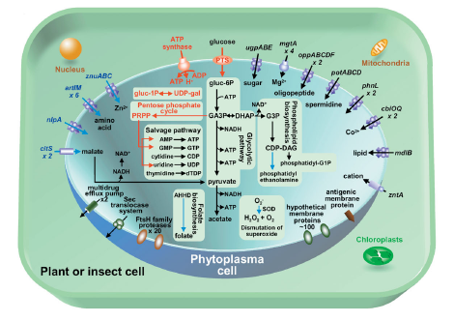
Phytoplasma cell

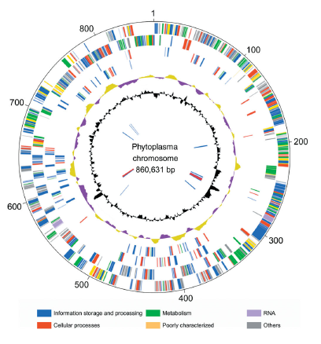
Phytoplasma chromosome

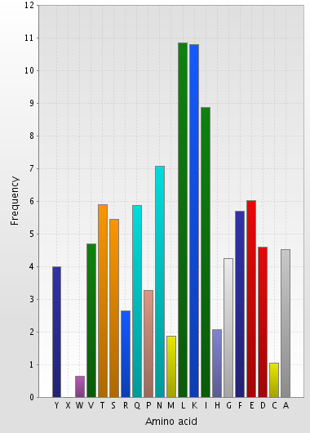
Amino acid | Total content | Frequency  [%]
A | 9178 | 4.51
C | 2111 | 1.04
D | 9345 | 4.59
E | 12237 | 6.02
 | 11568 | 5.69
G | 8641 | 4.25
H | 4193 | 2.06
I | 18032 | 8.87
K | 21932 | 10.78
L | 22045 | 10.84
M | 3784 | 1.86
N | 14390 | 7.08
P | 6638 | 3.26
Q | 11928 | 5.86
R | 5376 | 2.64
S | 11071 | 5.44
T | 11968 | 5.88
V | 9523 | 4.68
W | 1300 | 0.64
X | 2 | 0.00
Y | 8125 | 3.99
Aminoacid content of phytoplasma

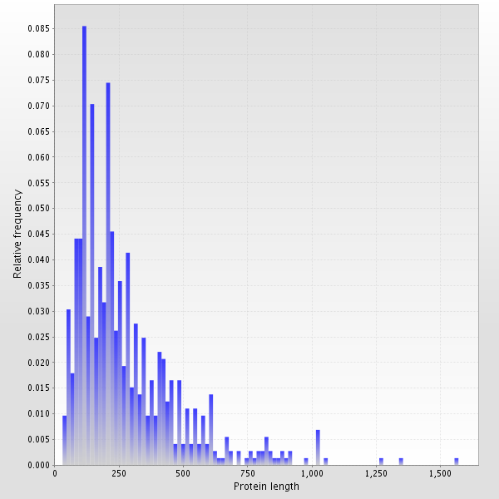
Analysis of full-length proteins [fragments excluded]
Average protein length: 280 +/- 204 amino acid residues
Size range: 33 - 1571 amino acid residues

