# ADT2_PONPY Length: 297
# ADT2_PONPY Number of predicted TMHs: 2
# ADT2_PONPY Exp number of AAs in TMHs: 67.1589
# ADT2_PONPY Exp number, first 60 AAs: 0.77574
# ADT2_PONPY Total prob of N-in: 0.34894
ADT2_PONPY TMHMM2.0 inside 1 110
ADT2_PONPY TMHMM2.0 TMhelix 111 133
ADT2_PONPY TMHMM2.0 outside 134 207
ADT2_PONPY TMHMM2.0 TMhelix 208 230
ADT2_PONPY TMHMM2.0 inside 231 297
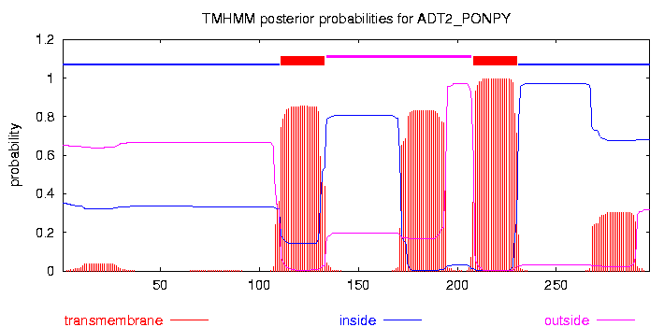
# plot in postscript, script for making the plot in gnuplot, data for plot

